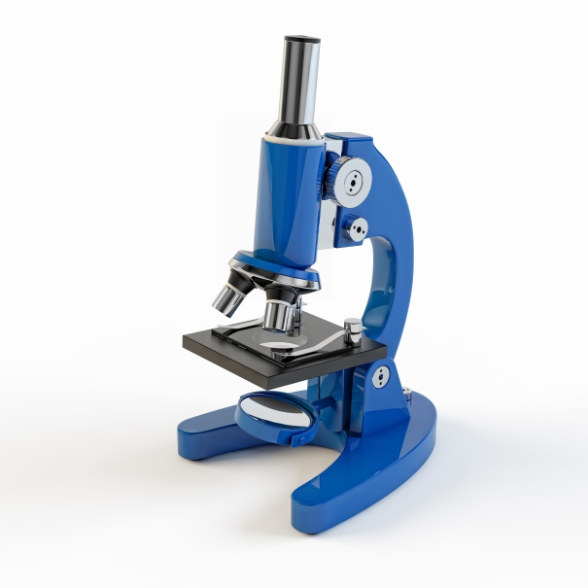Literacy support worksheet

6.1 All living things are made up of cells

Pages 96–97 and 196

Cells

1 Who made one of the first microscopes?

2 What did this scientist discover by looking at cork?

3 Draw and label what he saw under the microscope.

4 What scientific field of study did this scientist create in their work?

5 What are the three principals of cell theory?

6 What is a unicellular organism? Give an example.

7 What is a multicellular organism? Give an example.

8 What are microbes?

9 What is the function of the membrane of a cell?

10 Using Figure 6.4 in *Oxford Science 8 Western Australian Curriculum* as a guide, draw and label a unicellular organism. Include information on the cell membrane, nutrients, volume, surface area and why the surface area is important.

11 Explain why smaller cells are better able to survive.

12 Which of the cells below has a larger surface area to volume ratio? Explain your answer.

a 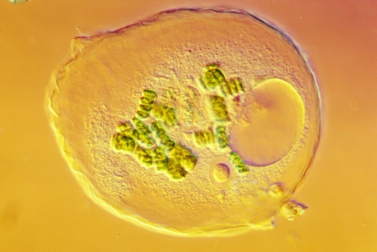 b 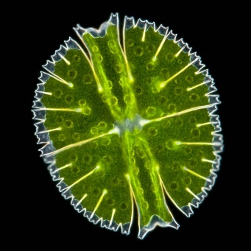

Word detective

13 Secret message

Use words from the student book to work out the secret message below.

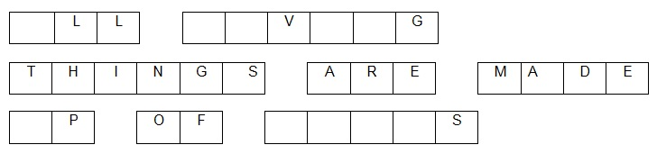

The invention of the \_\_\_\_\_\_\_\_\_\_\_\_\_\_\_\_\_\_\_\_\_\_\_\_ allowed scientists to see that all \_\_\_\_\_\_\_\_\_\_\_\_\_\_\_\_\_\_

things are made up of \_\_\_\_\_\_\_\_\_\_\_\_\_\_\_\_\_.

Literacy support worksheet

6.2 Microscopes are used to study cells

Pages 98–99 and 197

Microscopes

1 Label the parts of this microscope in the spaces provided.

**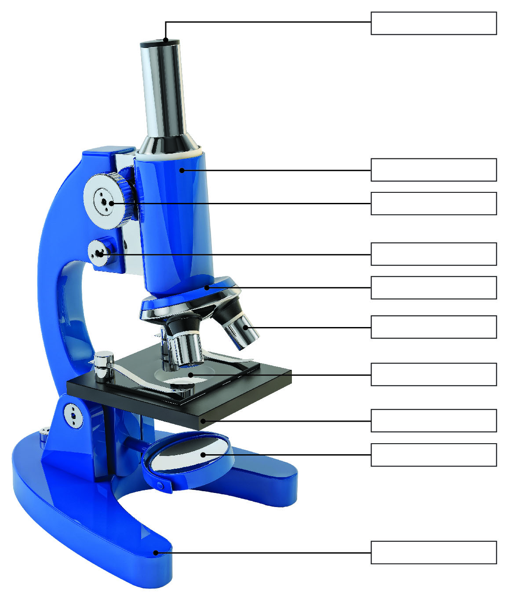**

2 What are the three types of microscopes?

3 Why are there three objective lenses on a compound light microscope?

4 Complete the table below to summarise the main differences between the three types of microscopes. Some of it has been completed for you.

|  |  |  |  |
| --- | --- | --- | --- |
|  | Compound Light Microscope | Stereo Microscope | Scanning Electron Microscope |
| What is it used to observe? |  | Larger objects  Whole insects |  |
| What is its magnification? |  |  | 1–50 million times |
| DIMENSION | 2D |  | 3D image |
| Can it see through an object or only the surface? |  | Surface of a specimen |  |
| Can it be used to see cells or whole organisms? | Cells and cell structures |  |  |

Word detective

5 Matching meaning

Draw a line to match the words on the left with the appropriate description sentence on the right.

**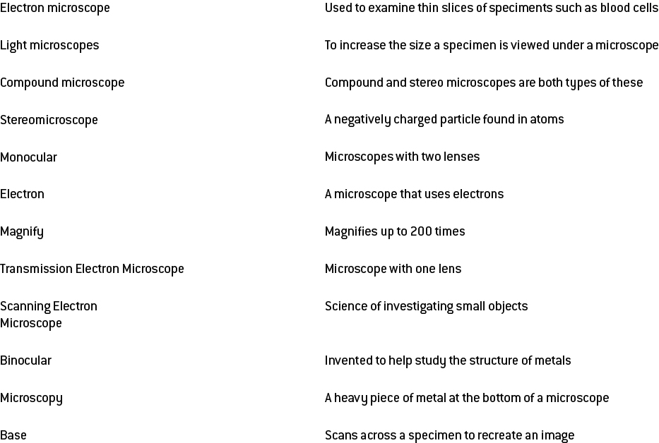**

Literacy support worksheet

6.3 Plant and animal cells have organelles

Pages 100–103 and 198–200

Cell organelles

1 What is a cellular organelle?

2 What is the function of the following cellular structures?

a cell membrane

b cytoplasm

c DNA

3 Label the organelles in the animal cell below.

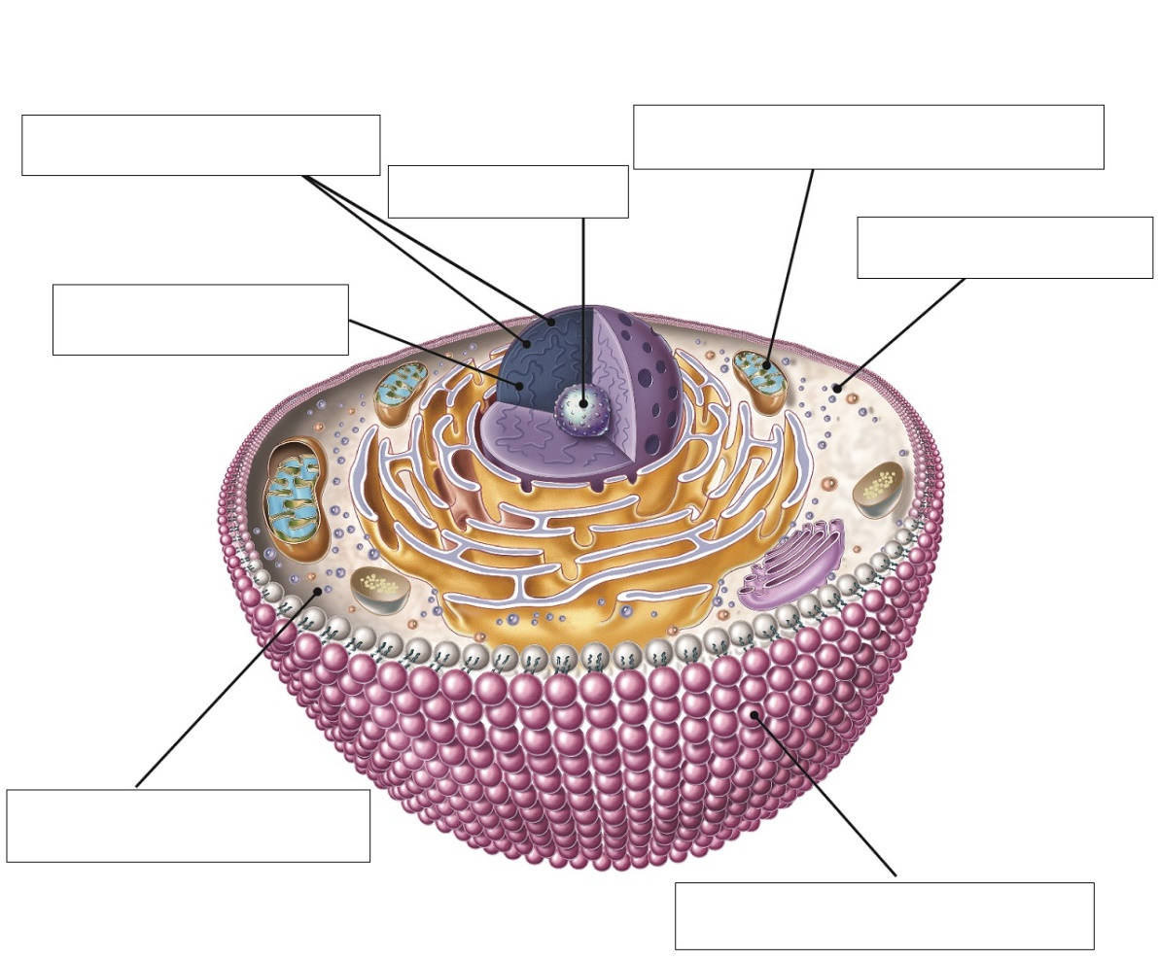

4 Label the organelles in the animal cell below.

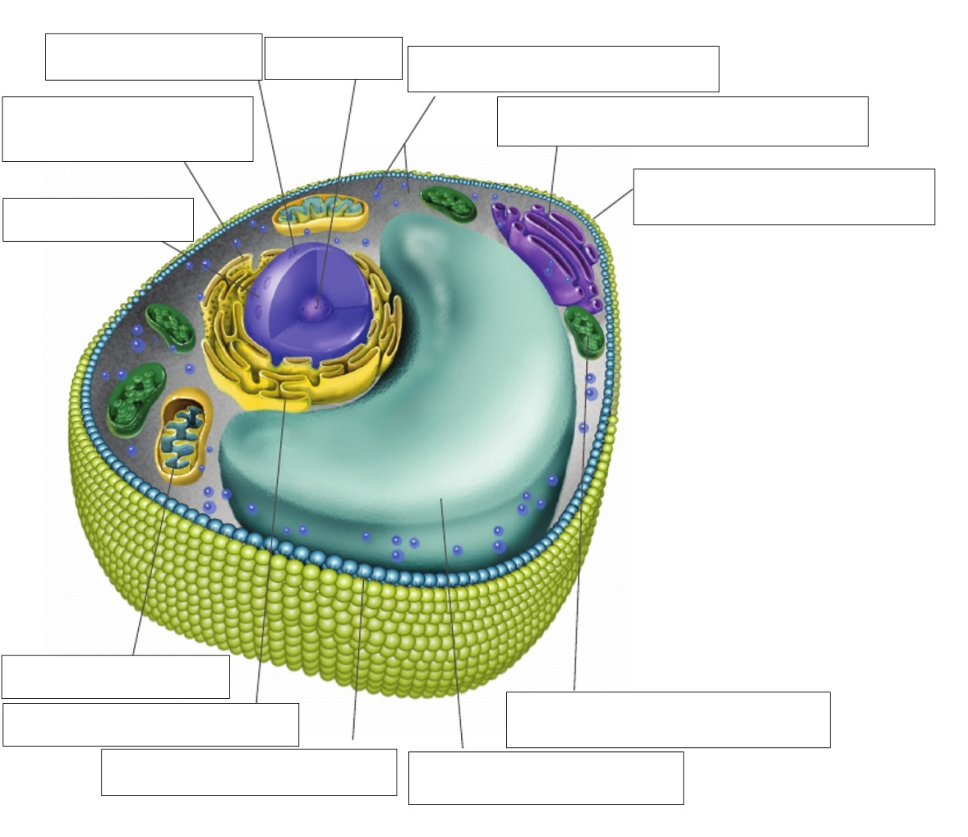

5 Complete the following Venn diagram by identifying which organelles belong to plants, animals or both.

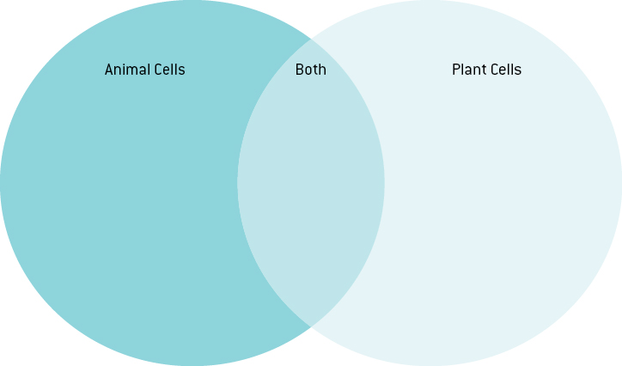

6 The chart below compares the size of different cells found in the human body. Measure each cell on p 103 of *Oxford Science 8* from left to right and write your answer below – that is, measure the length or diameter of the cell.

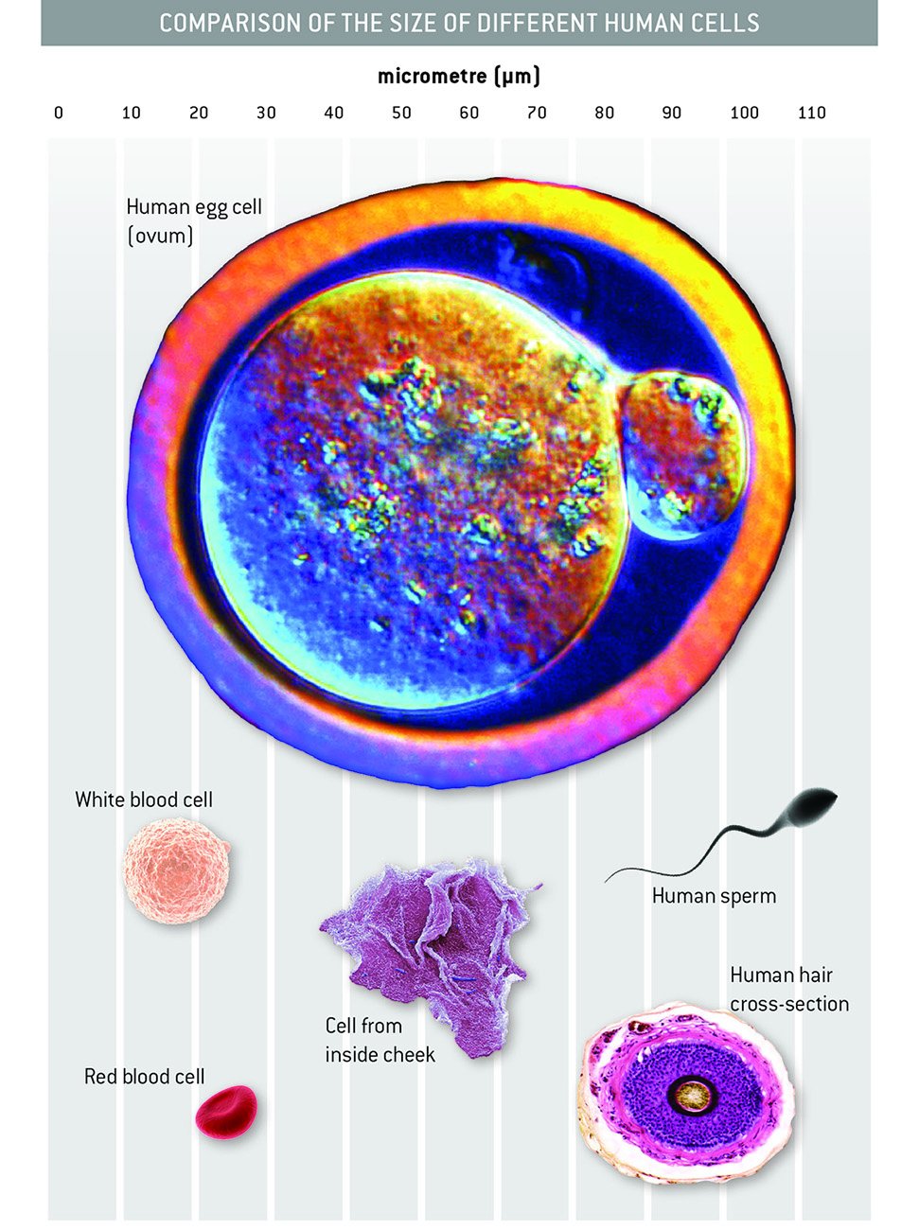

a Human egg cell (ovum):

b White blood cell:

c Red blood cell:

d Cell from inside cheek:

e Human sperm cell:

f Human hair cross-section:

Word detective

7 Draw and label

Draw and label a diagram of a mitochondrion. Including the following words: inner membrane, matrix, cristae, DNA, outer membrane, enzyme complexes. If you need to, you can refer to p 102 of the student book to help you with your diagram.

Literacy support worksheet

6.4 All organisms have cells that specialise

Pages 104–105 and 200–201

Specialised cells

1 What are the two main types of cells?

2 Create a list of the characteristics of these two main groups of cells.

|  |  |
| --- | --- |
| P \_\_\_\_\_\_\_\_\_\_\_\_\_\_\_\_\_\_\_\_\_\_\_\_\_\_\_\_\_\_\_ | E \_\_\_\_\_\_\_\_\_\_\_\_\_\_\_\_\_\_\_\_\_\_\_\_\_\_\_\_\_\_\_ |
|  |  |
|  |  |
|  |  |
|  |  |
|  |  |

3 State which kingdom the following cells belong to. Use the pictures on pp 100–105 of *Oxford Science 8 Western Australian Curriculum* to help you.

|  |  |
| --- | --- |
| D:\OS8 worksheets and aw\jpgs ready for worksheets\SW0614_00951-r.jpg | D:\OS8 worksheets and aw\jpgs ready for worksheets\SW0615_00951-rm.jpg |
| D:\OS8 worksheets and aw\jpgs ready for worksheets\SW0616_00951-r.jpg | D:\OS8 worksheets and aw\jpgs ready for worksheets\SW0617_00951-r.jpg |
| D:\OS8 worksheets and aw\jpgs ready for worksheets\SW0618_00951-rm.jpg | D:\OS8 worksheets and aw\jpgs ready for worksheets\SW0619_00951-rm.jpg |

Word detective

4 Mumbo jumbo

a Use the marked letters to find the secret word (e.g. olusntoi = solution).

b Unscramble each of the clue words below to find the message.

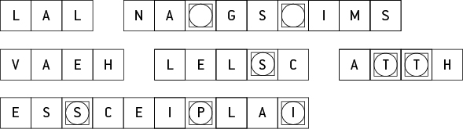

Secret word:

Message:

Literacy support worksheet

6.5 Bacteria are single-celled organisms

Pages 106–107 and 202

Bacteria – kingdom Monera

1 How many cells make up a single bacterial organism?

2 What is a pathogen?

3 What is a host?

4 What are three possible disease symptoms?

5 Name four types of harmful microbes and give two examples for each

|  |  |  |
| --- | --- | --- |
| Microbe | Example One | Example Two |
|  |  |  |
|  |  |  |
|  |  |  |
|  |  |  |

6 Why is it hard for our immune system to fight viruses?

7 Can we use antibiotics to kill viruses? Explain.

8 What is the process of cell division in bacteria called?

9 At what temperatures do bacteria grow?

10 The following graph show the number of bacterial cells present in a person during a one-week period.

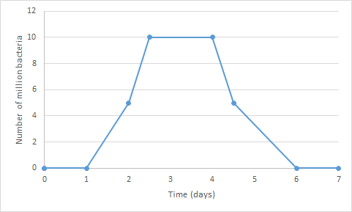

a When was the person producing the most of this bacteria?

b What could be the reason for this growth?

c When did this bacterial growth stop?

d What reason can you give for the bacterial growth stopping?

Word detective

11 Boggle

The words listed below are incomplete. Using the clues provided, find the words in the puzzle to complete each word

|  |  |  |  |  |  |  |  |  |  |  |  |  |  |
| --- | --- | --- | --- | --- | --- | --- | --- | --- | --- | --- | --- | --- | --- |
| L | L | E | C | | E | L | O | U | C | A | V | | S |
| V | I | R | U | | S | I | A | R | O | L | F | | U |
| D | B | I | N | | E | G | O | H | T | A | P | | R |
| L | O | S | U | | O | I | T | C | E | F | N | | I |
| O | D | A | S | | Y | M | P | T | O | M | S | | V |
| C | Y | U | I | | B | A | C | T | E | R | I | | A |
| S | E | M | O | | S | O | B | I | R | D | N | | A |
| WORD | | | | CLUE | | | | | | | |
| \_ E L \_ | | | | Each of these has a nucleus. | | | | | | | |
| R\_ \_ \_ \_ \_ \_ \_ | | | | This is where protein is produced within a cell. | | | | | | | |
| D\_ \_ | | | | This carries genetic information in each person. | | | | | | | |
| C\_ \_ \_ | | | | A common type of virus. | | | | | | | |
| B\_ \_ \_ | | | | Harmful viruses can invade the human \_ \_ \_ \_. | | | | | | | |
| B\_ \_ \_ \_ \_ \_ \_ | | | | These have cell walls and contain DNA, but do not have a nucleus. | | | | | | | |
| V\_ \_ \_ \_ | | | | Scientists consider this to be a non-living pathogen. | | | | | | | |
| F\_ \_ \_ \_ | | | | The microbes that live on our bodies are natural \_ \_ \_ \_ \_. | | | | | | | |
| S\_ \_ \_ \_ \_ \_ \_ | | | | These changes occur to a person as a consequence of disease. | | | | | | | |
| V\_ \_ \_ \_ \_ \_ \_ | | | | The space within the cytoplasm of a cell. | | | | | | | |
| P\_ \_ \_ \_ \_ \_ \_ | | | | This is a microorganism that can potentially cause disease. | | | | | | | |
| I\_ \_ \_ \_ \_ \_ \_ \_ \_ | | | | \_ \_ \_ \_ \_ \_ \_ \_ \_ \_ diseases may pass from one organism to another. | | | | | | | |

Literacy support worksheet

6.6 Eukaryotic cells undergo mitosis

Pages 108–109 and 203

Mitosis

1 Name three functions your cells have to carry out for survival:

2 What is the purpose of DNA?

3 What happens to the DNA before a cell splits to reproduce?

4 Label the process of mitosis on the diagram below.

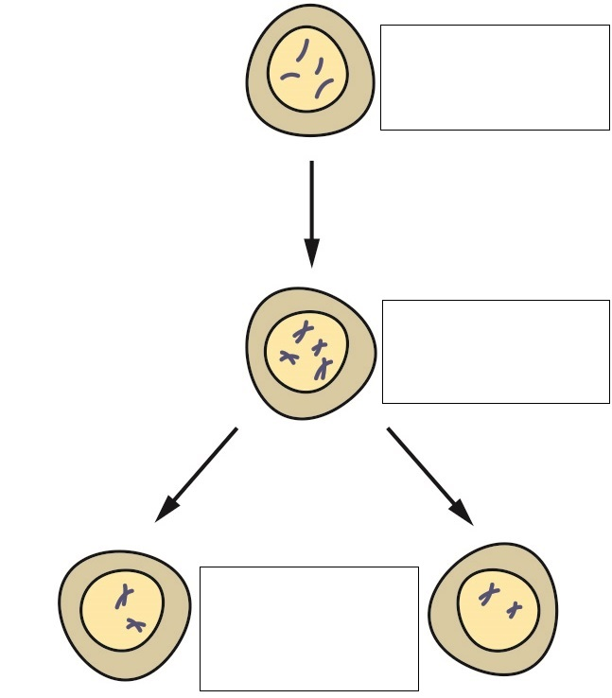

5 What is mitosis?

6 What is cancer?

7 Name three ways DNA can become damaged by mutagens:

8 What is a carcinogen?

9 What is a tumour?

10 What is a secondary cancer?

11 There are the two types of tumour, benign and malignant. Define each.

a Benign tumours:

b Malignant tumours:

Word detective

12 True or false

Read the statement and circle whether it is true or false.

a During mitosis cells split in half T or F

b Mutagens are new cells T or F

c Carcinogens are old cells T or F

d Tumours grow when cell division gets out of control T or F

e Tumours can split and spread causing secondary cancers T or F

f Malignant tumours are not fatal T or F

g The death of a cell is called apoptosis T or F

h New cells created by mitosis are called son cells T or F

Literacy support worksheet

6.7 Fungal cells can save lives

Pages 110–111

Using cells to save lives

1 Before antibiotics, what could have happened if you had a simple break in the skin?

2 What is a key property of mould that makes it essential to medicine?

3 What discovery was made in 1928 by Alexander Fleming?

4 This discovery was an accident. Write a, b, or c next to each sentence to place them in order.

\_\_\_ He concluded that the mould (penicillium) was stopping the bacteria from growing.

\_\_\_ Fleming was investigating bacterial growth and did not clean up properly before a holiday.

\_\_\_ Upon returning he discovered that bacteria could not grow where the mould had formed.

5 Where had the small spot of mould grown and what was happening around it?

6 How does this medicine stop bacterial growth/infection?

7 Who developed a method to isolate penicillin?

8 A group of specialists got together to produce penicillin. Name the steps they took to do this:

a

b

c

d

9 Draw a line to match the dates on the left with the events on the ‘Penicillin Timeline’ on the right.

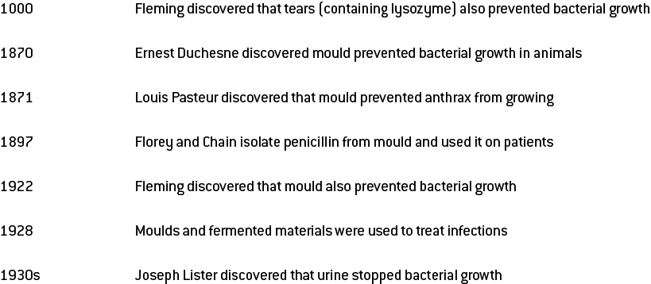

Word detective

10 Testing penicillin

Number each of the following sentences from 1 to 7, to complete the order of the experiment which tested penicillin in May 1940.

\_\_\_\_\_\_ Conclusion: Penicillin killed the streptococcal bacteria in the treated mice.

\_\_\_\_\_\_ Eight mice were infected with streptococcal bacteria.

\_\_\_\_\_\_ Prediction: Mould prevents bacterial growth.

\_\_\_\_\_\_ Mice treated with penicillin lived.

\_\_\_\_\_\_ Four of the mice were treated with penicillin.

\_\_\_\_\_\_ Mice who were not treated died.

\_\_\_\_\_\_ Four of the mice were NOT treated with penicillin.